

Juz will release their 7th single “Needle Down” themed around "love for vinyl" on March 25
February 26, 2026

Juz, a three-piece rock band known for their driving songs that pursue riffs and grooves, will release their 7th single, "Needle Down" on March 25, 2026.

Juz's 5th release, "Reboot" is gaining attention with over 100 radio airplay across Europe, North America, Asia and other regions (Source: MusicDNA Report). Despite being completely unknown, the music video surpassed 10,000 total views shortly after the previous release.

Like previous releases, this song has been written, composed, and artwork designed by vocalist and guitarist Juz. The music video for this song - themed around "love for vinyl", was shot with the band members paying homage by dressing as musicians from the 70's. This is a song that showcases Juz at their best, featuring a crunchy guitar sound intertwined with a pulsing groove.

The recording took place in April 2024. Until then, Juz had built their career as a four-piece band. However, just before recording, their former guitarist left, forcing vocalist Juz to suddenly take on guitar duties as well, resulting in the band becoming a trio.
"When I heard he intended to leave the band, my mind went blank. There was no other option but for me to play guitar, so I did.” said Juz. "Once we became a trio, I felt this was the natural form Juz should have been. Even when things seem hopeless, if you just try, you can make it work. We created something amazing, and I'm surprised myself.”

Why "love for vinyl" now? “I thought it was culturally cool to deliberately embrace the inconvenience of vinyl records in this day and age.” said Juz. “I don't think we should go back to the record era at all. Actually, I didn't even have a record player until the video shooting for this song. I just wanted to pay respect to the pioneers with this song.”

The music video for this song is scheduled to be released on Juz's YouTube channel on March 28, 2026. A commemorative live performance will be held at Black & Blue in Kichijoji, Tokyo, on March 24th.

Music Video for Preview（YouTube）： https://youtu.be/63jkp_NI_-Q

Short Bio

2014 Started their band career as “Juz”. Guitarists were changing one after another.
March, 2024 The former guitarist has left the band
April, 2024 Vocalist Juz starts playing guitar as well and proceeds with recording. The lineup becomes a trio.
January, 2025 First album "Freeedom" released early on CD, followed by singles and music videos via streaming services and YouTube.
December, 2025 Their single "Reboot" is being broadcast on radio stations across Europe, North America, Asia and other regions.
January, 2026 Total YouTube views have surpassed 10K.
March, 2026 The latest single "Needle Down" release

Download Assets

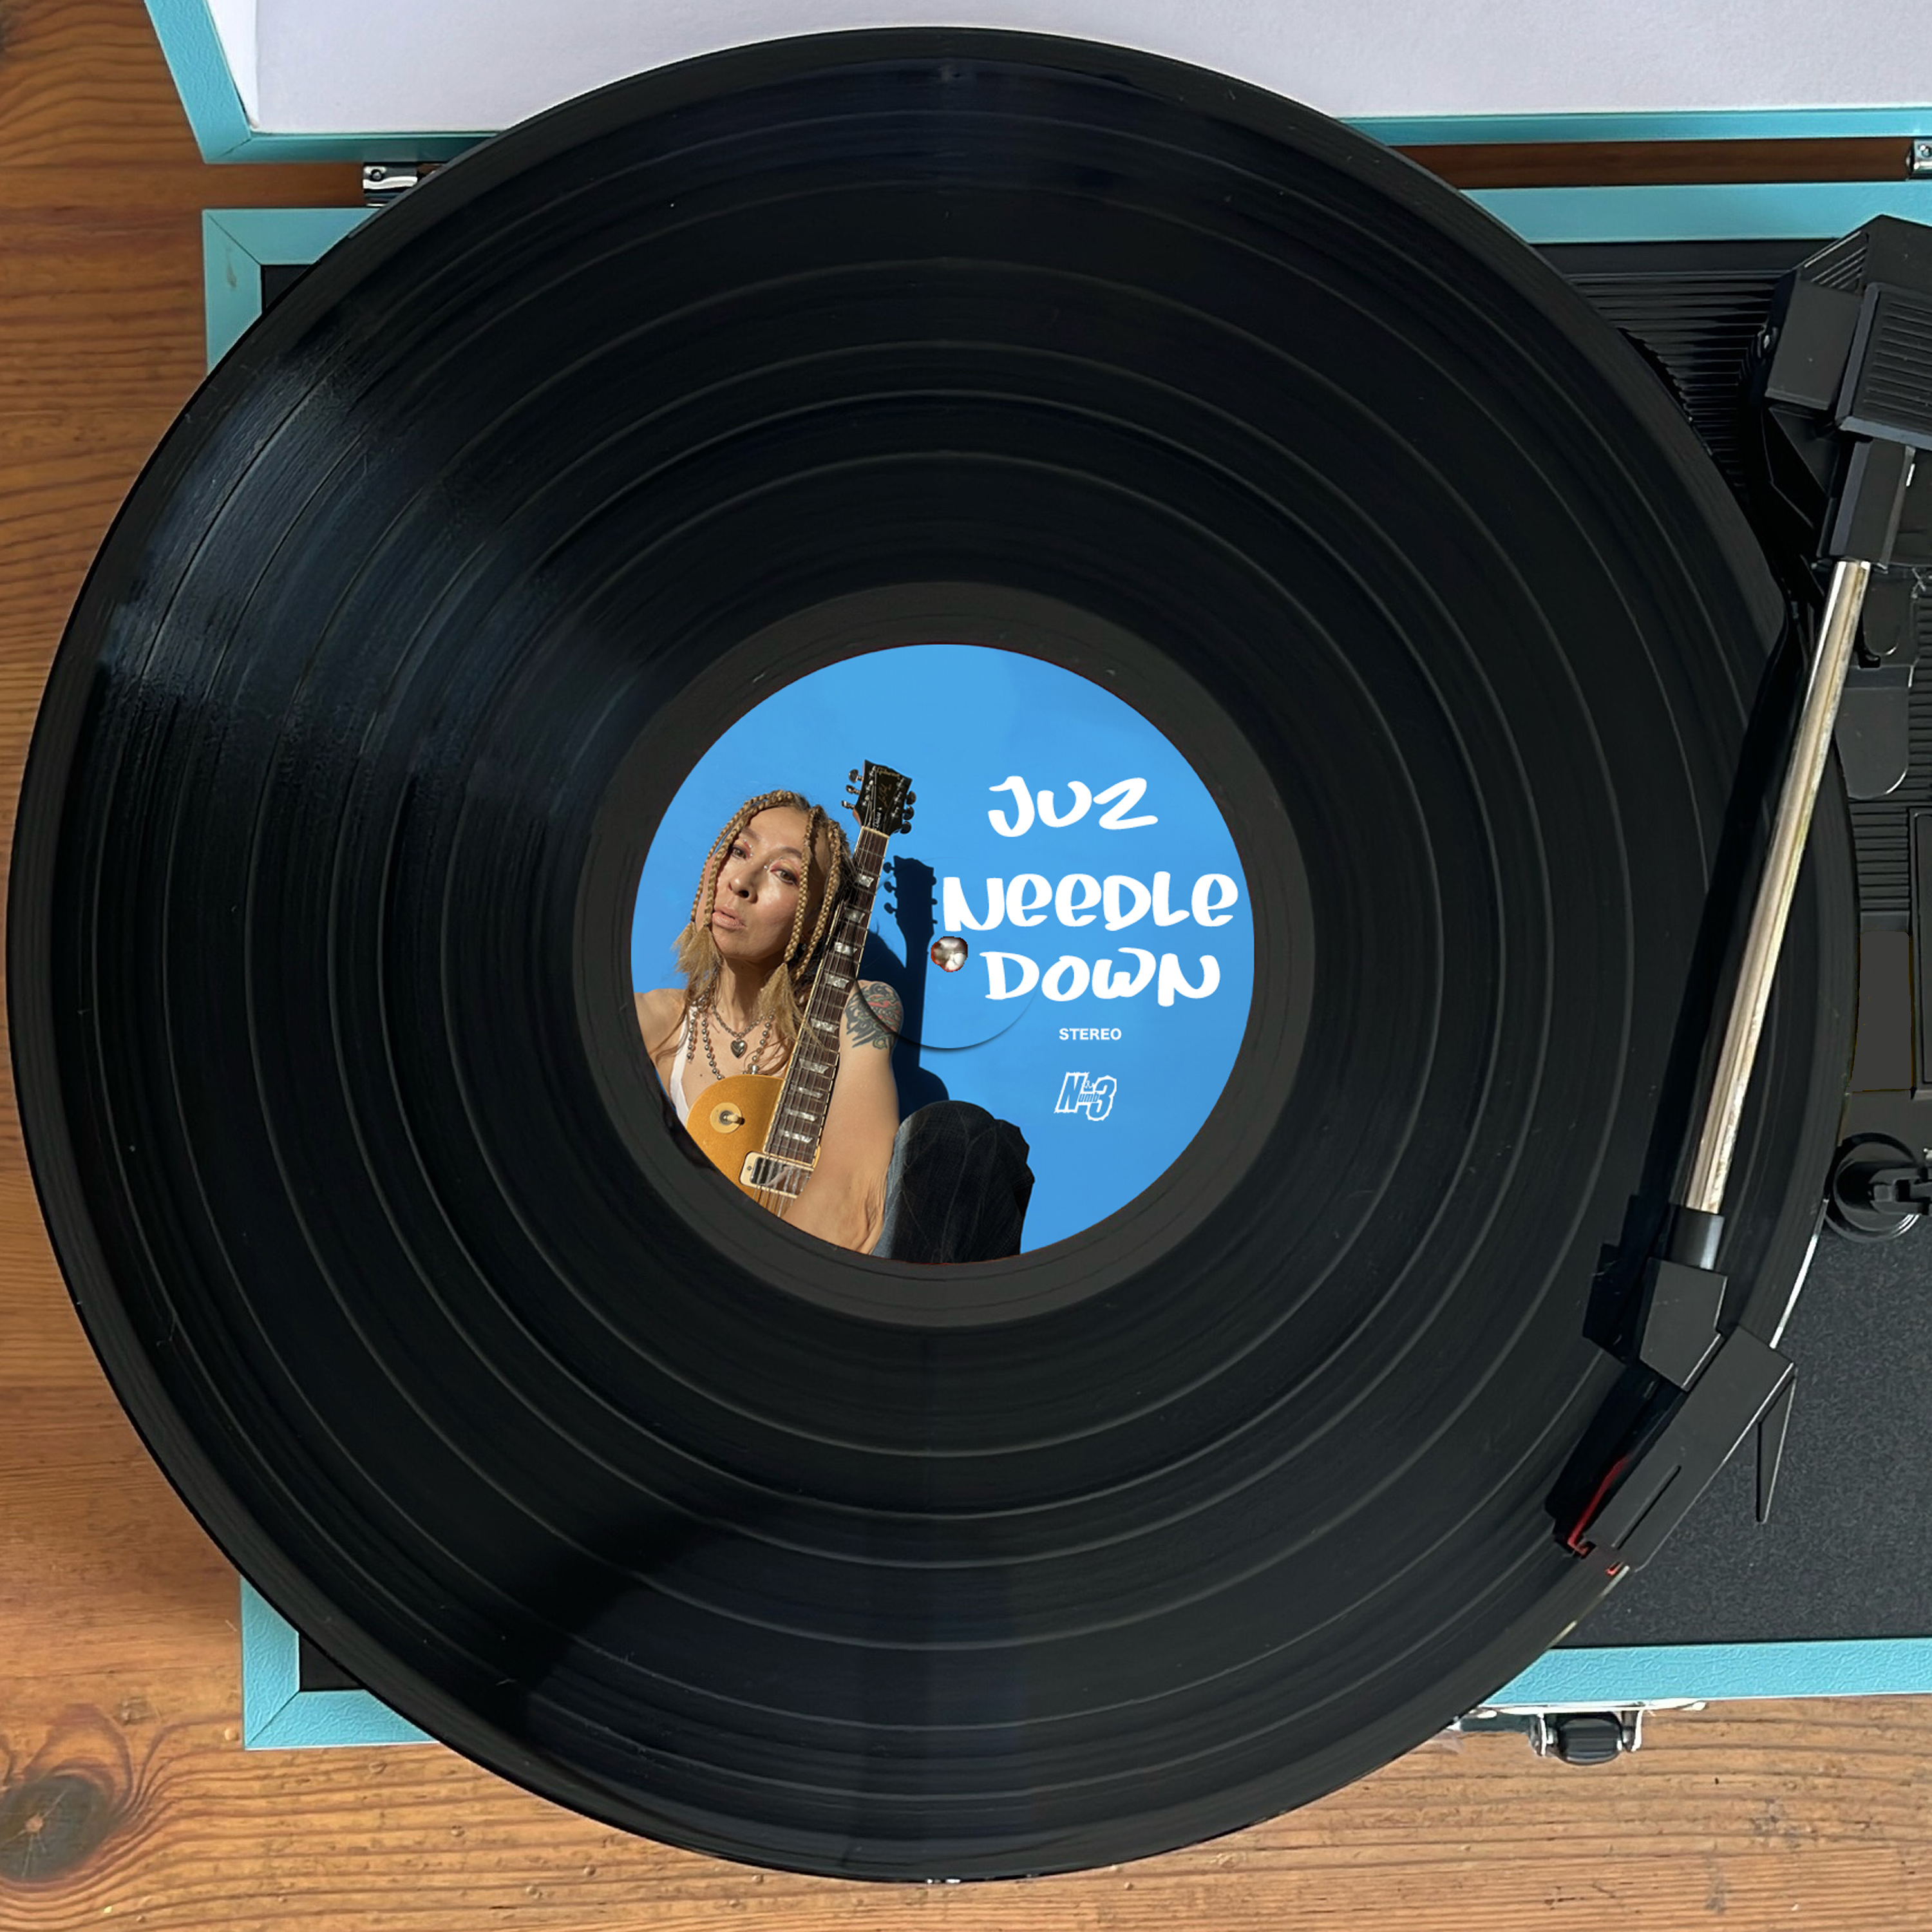
Artwork: Juz “Needle Down”
2400px x 2400px, jpg
Photo credit: Ⓒ Juz



Juz official artist image
Horisontal：2400 px x 1850 px, jpg
Square：2400 px x 2400 px
Photo credit: Ⓒ Megumi Shiina / Juz

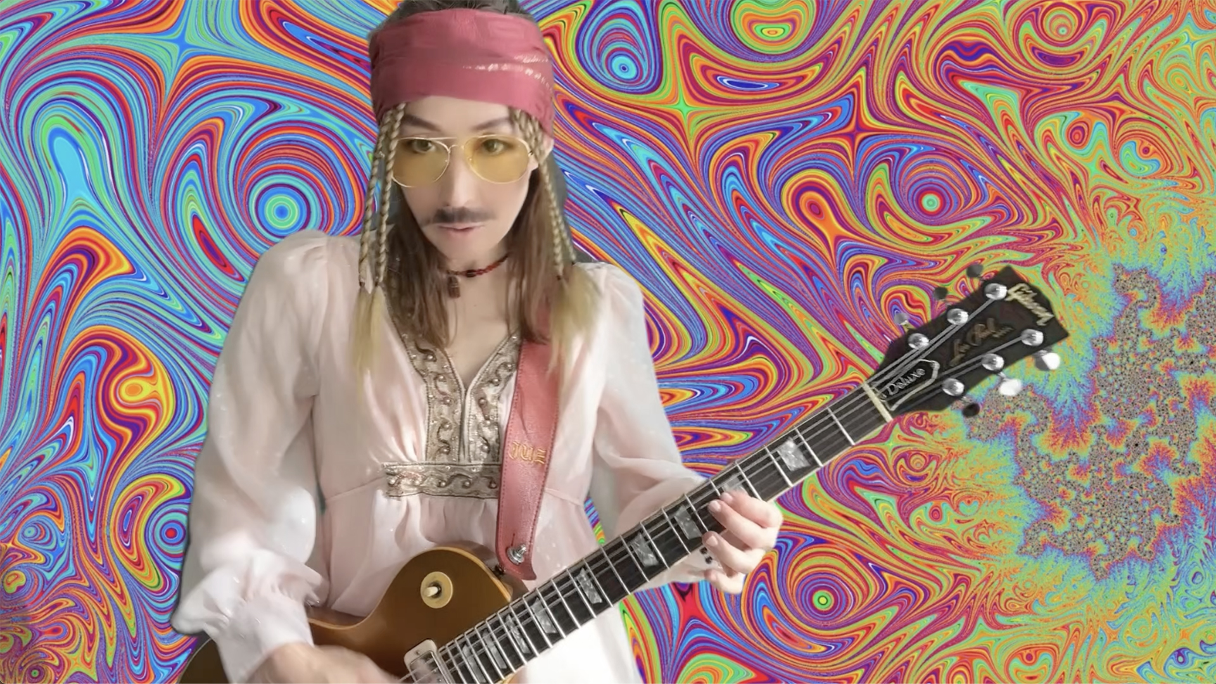
Music Video「Needle Down」Thumbnail
2400px x 1346 px, png
Photo credit: Ⓒ Juz

Contact： Numb3 Records info@numb3-records.com

Websites
Juz Official Website : https://www.juzrock.com
Już EPK : https://www.juzrock.com/press/epk-en.html
Numb3 Records : https://numb3-records.com/

Social Media
Juz Facebook : https://www.facebook.com/juzrocktokyo/
Juz X : https://x.com/Juzglorious
Juz Instagram : https://www.instagram.com/juzrocktokyo/
Juz YouTube : https://www.youtube.com/user/JuzGlorious
Juz TikTok : https://www.tiktok.com/@juz1438

